DOCUMENT 1: REACT JS
Chapter 1: Introduction to ReactJS
1.1 Overview
ReactJS is an open-source JavaScript library used for building user interfaces, specifically for
single-page applications (SPAs). It was developed by Facebook (Meta) and is maintained by a
community of developers. Unlike other frameworks like Angular, React is a "library" focused
exclusively on the "View" layer of the Model-View-Controller (MVC) architecture.
1.2 Why Use React?
In traditional web development, updating the DOM (Document Object Model) is expensive
and slow. React solves this by introducing the Virtual DOM. It allows developers to create
large web applications that can change data, without reloading the page.
1.3 Key Features
1
. Virtual DOM: React creates an in-memory data structure cache (Virtual DOM). When
the state of an object changes, React updates the virtual DOM first. It then compares
this with the real DOM (a process called "Diffing") and updates only the objects that
have actually changed.
2
. Component-Based Architecture: React builds applications using encapsulated
components that manage their own state. These components can be composed to
make complex UIs.
3
4
. One-Way Data Binding: Data in React flows in a single direction (from parent to
child) via "props". This makes the code more predictable and easier to debug.
. JSX (JavaScript XML): React uses a syntax extension called JSX. It allows you to write
HTML structures directly inside JavaScript code, making the structure of the
component easier to visualize.
1.4 Disadvantages
•
•
Pace of Development: The environment changes so fast that documentation can
become outdated quickly.
"Just a View Library": It covers only the UI layers; you need other technologies (like
Redux for state, Router for navigation) to build a complete app.
Chapter 2: React Components & Props

2.1 Functional vs. Class Components
React supports two types of components:
•
•
Functional Components: Simple JavaScript functions that accept props and return
React elements.
Class Components: ES6 classes that extend React.Component and have a render()
method. They can hold "state" and lifecycle methods.
2.2 Props (Properties)
Props are read-only components. They allow you to pass data from a parent component
down to a child component.
•
Prop Types: You can enforce type checking using PropTypes (e.g., ensuring a billNo is
a number, not a string).
Example of PropTypes:
import PropTypes from 'prop-types';
class Sum extends React.Component {
render() {
return <p>Sum: {this.props.num1 + this.props.num2}</p>
}
}
Sum.propTypes = {
num1: PropTypes.number, // Validates input is a number
num2: PropTypes.number
}

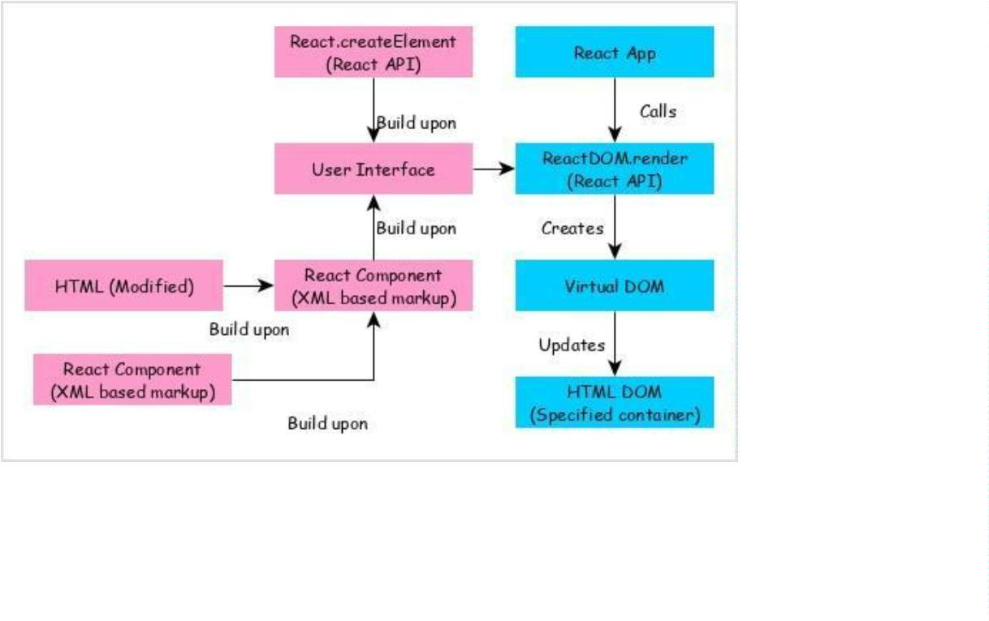
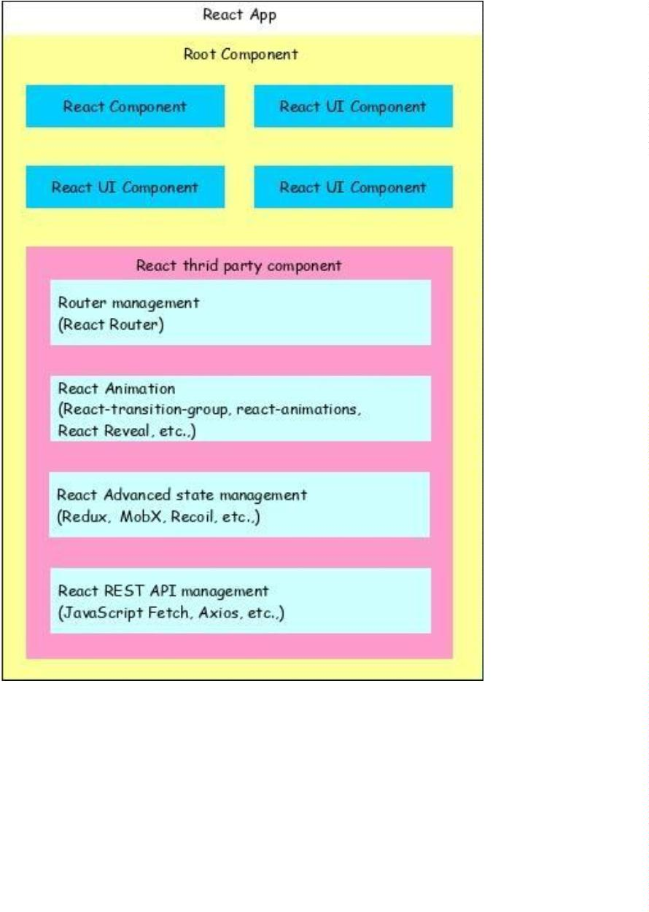

Chapter 3: Project Implementation (The Billing App)
3.1 Requirement
We need to create a Billing Application that displays bill details (Bill No, Vendor, Address,
GST) and a list of items. We will use two components: BillEntry (for the header details) and
ExpenseEntryItemList (for the table of items).
3.2 Source Code
File 1: App.js (Main Container)
import React from 'react';
import BillEntry from './BillEntry';
import ExpenseEntryItemList from './ExpenseEntryItemList';
function App() {
const items = [
{
id: 1, name: "Mango Juice", amount: 30.00, spendDate: "2020-10-10", category:
"Food" },
{
id: 2, name: "Pizza", amount: 250.00, spendDate: "2020-10-11", category: "Food" }
]
;
return (
div className="App">
<
<h1>Billing System</h1>
<BillEntry
billNo="23456712"
vendor="Mangaraju"
addr="St. Street, Mumbai"
gst="A20201010H"
/
>
<ExpenseEntryItemList items={items} />

</div>
)
;
}
export default App;
File 2: BillEntry.js (Header Component)
import React from 'react';
import './BillEntry.css';
class BillEntry extends React.Component {
render() {
return (
<div className="bill-info">
<h3>Invoice Details</h3>
<div><b>Bill No:</b> <em>{this.props.billNo}</em></div>
<div><b>Vendor Name:</b> <em>{this.props.vendor}</em></div>
<div><b>Address:</b> <em>{this.props.addr}</em></div>
<div><b>GST No:</b> <em>{this.props.gst}</em></div>
<hr/>
</div>
)
;
}
}
export default BillEntry;
File 3: ExpenseEntryItemList.js (Table Component)
import React from 'react';
class ExpenseEntryItemList extends React.Component {
render() {

const lists = this.props.items.map((item) =>
tr key={item.id}>
<
<td>{item.name}</td>
<
<
<
td>{item.amount}</td>
td>{new Date(item.spendDate).toDateString()}</td>
td>{item.category}</td>
</tr>
)
;
return (
table border="1" style={{width: '100%', marginTop: '20px'}}>
thead>
tr>
<
<
<
<
<
<
<
th>Item</th>
th>Amount</th>
th>Date</th>
th>Category</th>
<
/tr>
/thead>
tbody>
lists}
/tbody>
/table>
<
<
{
<
<
)
;
}
}
export default ExpenseEntryItemList;

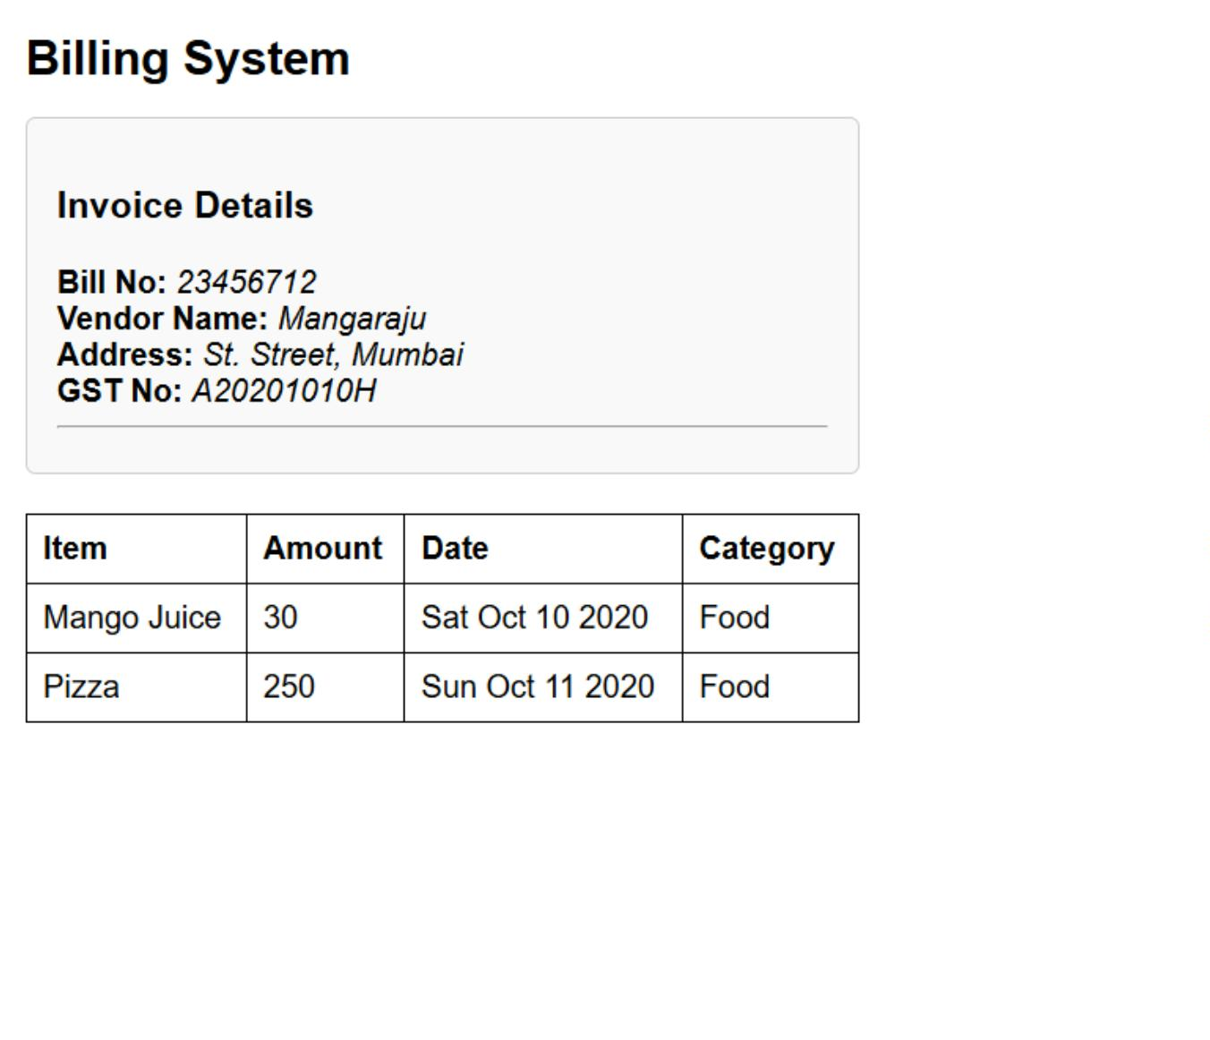
3.3 Output

